**LinkedIn User project Management:**

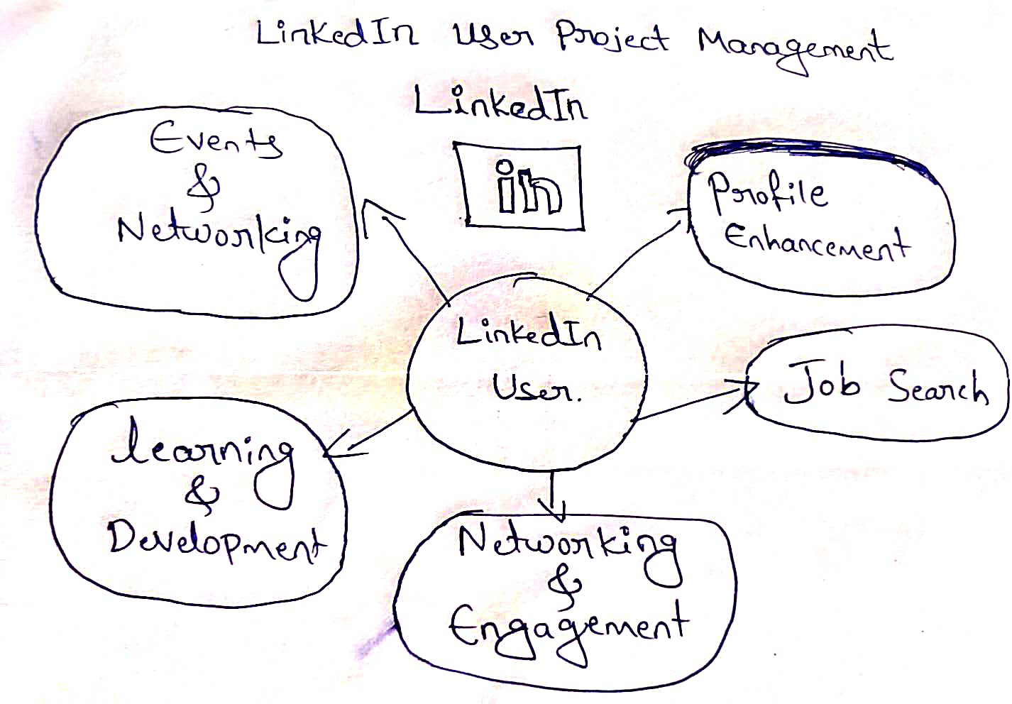

**EPIC: Profile Enhancement**

* **As a job seeker,** I want to be able to upload and maintain a professional profile picture, so that recruiters and employers get a positive first impression of me.
* As a recruiter, I want to see endorsements and recommendations on a candidate's profile, providing additional insights into their abilities and character.
* As a freelancer, I want to showcase my portfolio or past projects on my profile, demonstrating my expertise to potential clients.
* As an employer, I want to easily verify a candidate's qualifications and credentials by viewing their education and certifications on their profile.

**EPIC: Job Search**

* As a job seeker, I want to set up job alerts based on specific keywords and criteria, so that I am notified of relevant job openings.
* As a recruiter, I want to filter and sort candidate search results based on various criteria (e.g., location, experience), making it easier to find suitable candidates.
* As an employer, I want to sponsor job postings to increase their visibility and attract a larger pool of qualified candidates.

**EPIC:** Networking and Engagement

* As a student, I want to join industry-specific LinkedIn groups to connect with professionals and participate in discussions relevant to my field of study.
* As a content creator, I want to schedule posts in advance and analyse post engagement metrics, optimizing my content strategy.
* As a sales professional, I want to use LinkedIn's InMail feature to send personalized messages to prospects, increasing my chances of engagement.

**EPIC:** Learning and Development

* As an educator, I want to create and share educational content (e.g., articles, videos) on LinkedIn to reach a wider audience and establish credibility in my field.
* As a researcher, I want to access industry reports and insights on LinkedIn to stay updated on trends and developments in my field.

**EPIC :** Events and Networking

* As a professional, I want to discover and RSVP to industry events and networking opportunities on LinkedIn, expanding my professional network.
* As an event organizer, I want to create and promote events on LinkedIn, attracting attendees and generating interest.

**Scrum Framework:**  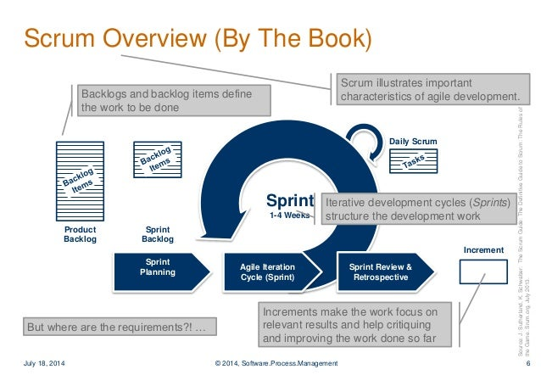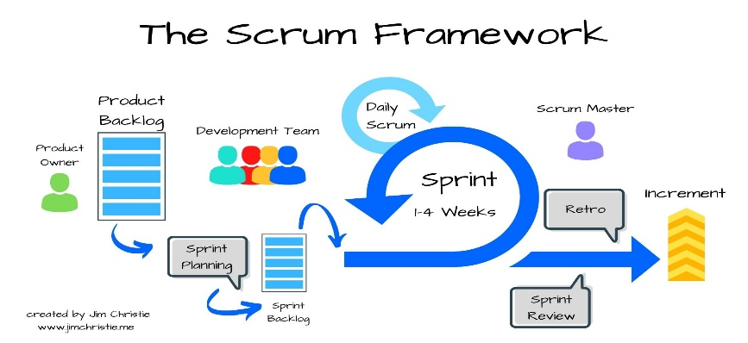

**Scrum:** Scrum is an **agile framework** for managing and delivering complex projects, primarily in software development, but it has been widely adopted in various other fields as well.

**1.Product Owner:**

The Product Owner is a member of the Scrum Team and works closely with both the Development Team and stakeholders to ensure that the product backlog is well-defined, prioritized, and understood.

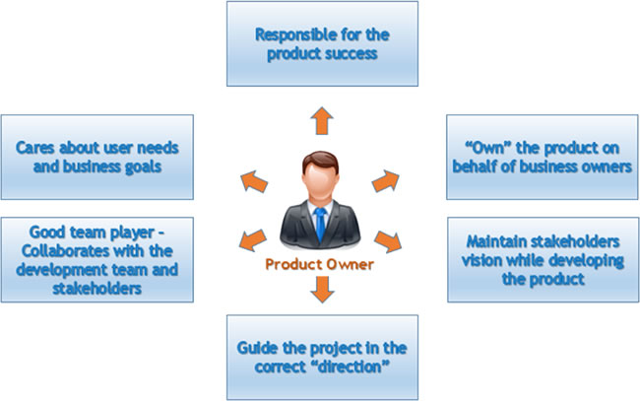

**2.Product Backlog:**

* Requirements for the entire product.
* Owned by product owner.
* Term used in agile project.
* In the form of User stories, Features and Epics.
* Ordered based on the business priority number.
* Technical stories to enable the product features.
* Current status of each user story will be captured in the Product Backlog.

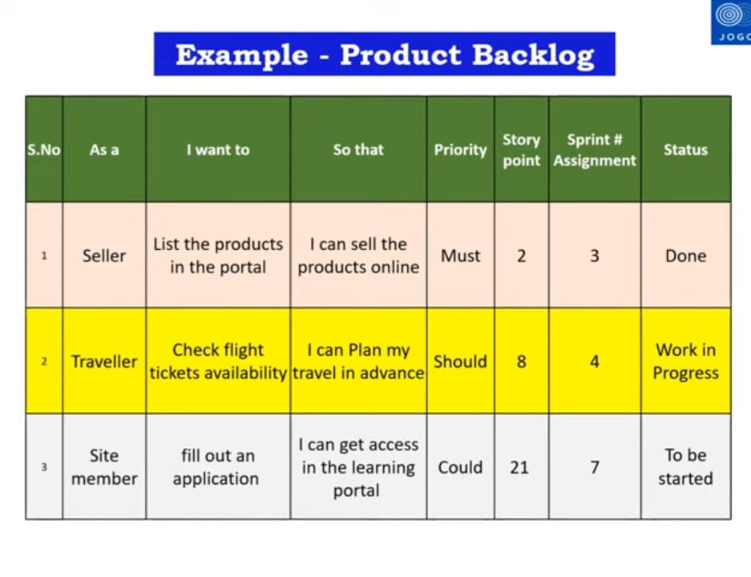

**3.Sprint Planning:** Sprint Planning is a key event in the Scrum framework that occurs at the beginning of each Sprint.

It is a collaborative meeting where the Scrum Team (including the Product Owner, Scrum Master, and Development Team) comes together to plan the work that will be completed during the upcoming Sprint.

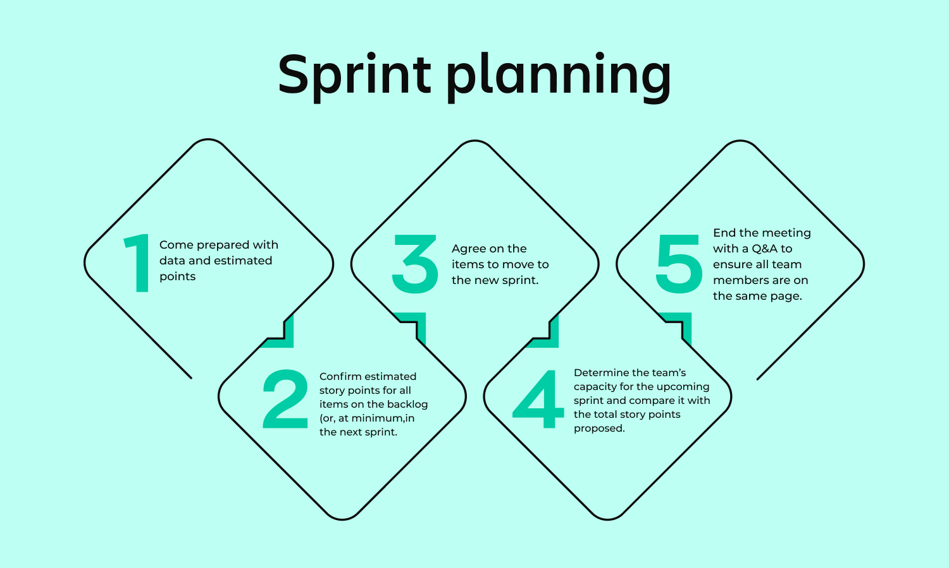

**4. Sprint Backlog:** Subset of the Product Backlog items selected for implementation in the current Sprint.

* Owned by the development team.
* Technical tasks related to user stories.
* Effort estimates in hours for tasks.
* Identifies as part of sprint planning meeting.

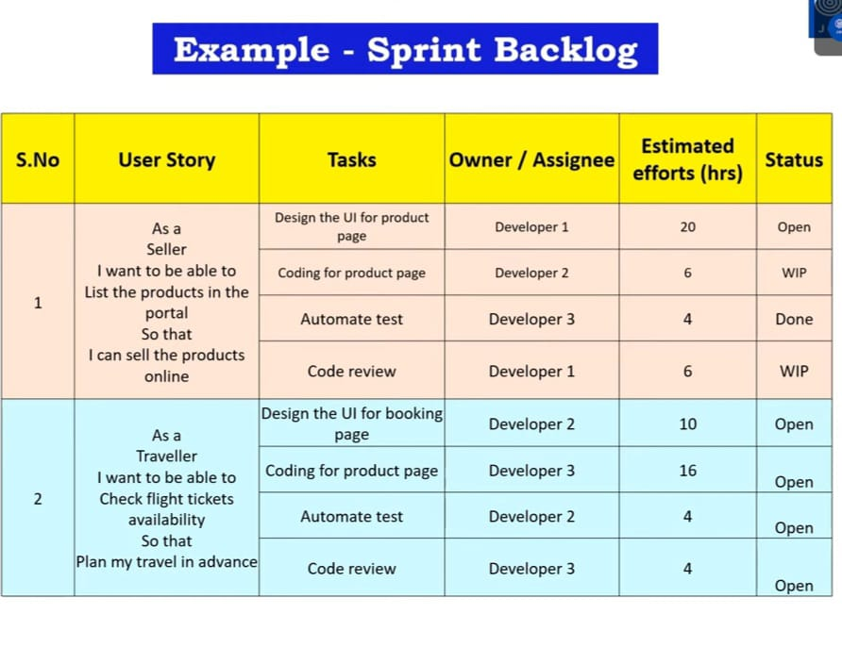

**5. Sprint:**

* Sprint is a time-boxed iteration during which a specific amount of work is completed by the Development Team.
* Sprints are a fundamental aspect of the Scrum framework and typically have a fixed duration, usually ranging from one to four weeks.
* The duration of a Sprint is determined during the project's initial planning and remains consistent throughout the project.
* Sprints in Scrum provide a structured approach to iterative and incremental development, allowing teams to deliver value in regular, predictable intervals while maintaining flexibility and adaptability to changing requirement.

**Key aspects of Sprints in Scrum :**

* **Daily Stand-up:** Throughout the Sprint, the Development Team holds a Daily Stand-up meeting to synchronize their activities, discuss progress, and identify any obstacles or impediments that may affect their ability to achieve the Sprint Goal.
* **Increment:** The Increment is the sum of all the completed and potentially shippable product backlog items at the end of the Sprint. It represents the work completed by the Development Team during the Sprint and serves as the foundation for the next Sprint.

**6. Sprint Review :**

* The Sprint Review is an essential event in the Scrum framework that occurs at the end of each Sprint.
* The Sprint Review concludes with a review of the Sprint Goals and objectives. The Scrum Team discusses whether the Sprint Goals were achieved and identifies any areas for improvement.

**7.** **Sprint Retrospective:**

* Insights and lessons learned from the Sprint Retrospective, which is held immediately after the Sprint Review, may also inform discussions during the Sprint Review.
* The Sprint Retrospective focuses on process improvements and team dynamics, providing valuable insights that can help enhance future Sprint Reviews and overall product development.

**8.** **Increment:**

* The Increment is the sum of all the completed and potentially shippable product backlog items at the end of the Sprint. It represents the work completed by the Development Team during the Sprint and serves as the foundation for the next Sprint.

**9. Scrum Master:**

* Scrum Master plays a pivotal role in enabling the Scrum Team to deliver value effectively and efficiently.
* They serve as a facilitator, coach, mentor, and servant-leader, helping the team navigate challenges, overcome obstacles, and achieve their goals within the Scrum framework.

Top of Form